- Jolene Adams was a student with an interest in helping fight “food insecurity” in St. Louis.
Read the whole Mini Case on page 25 of your Textbook. Also watch the youtube videos associated with the mini case and check the website mentioned in the mini-case and discuss the following questions:

1) What do you think are the advantages and disadvantages of the corporate, social, and independent entrepreneurial approaches outlined in the case?
2) How would you feel about being a corporate entrepreneur who is part of an existing organization? How about as an independent or social entrepreneur starting your own organization from scratch?
3) All businesses need to break even financially to be seen as workable. For-profit businesses also typically measure how much profit they make as one metric of their success. But businesses can also measure the impact they have on their communities, customers, economies and environment. What kind of impact measure might it make sense to consider for the proposed market? Does it change depending on the kind of CSI entrepreneurship approach you choose?

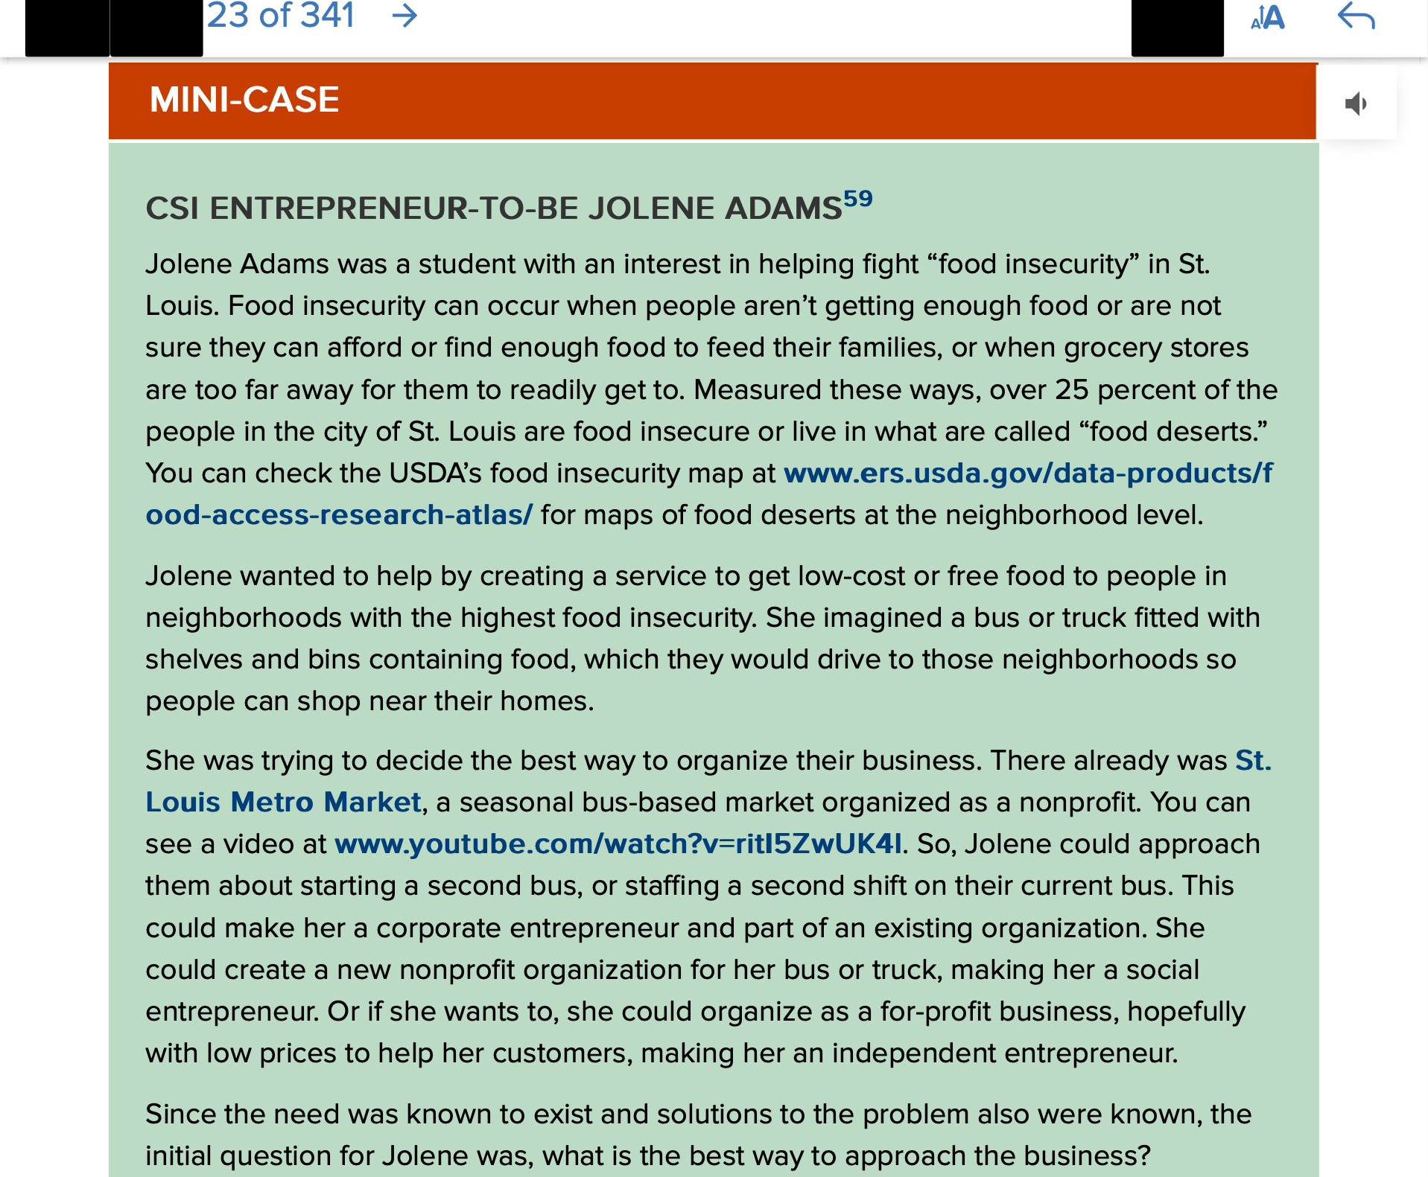
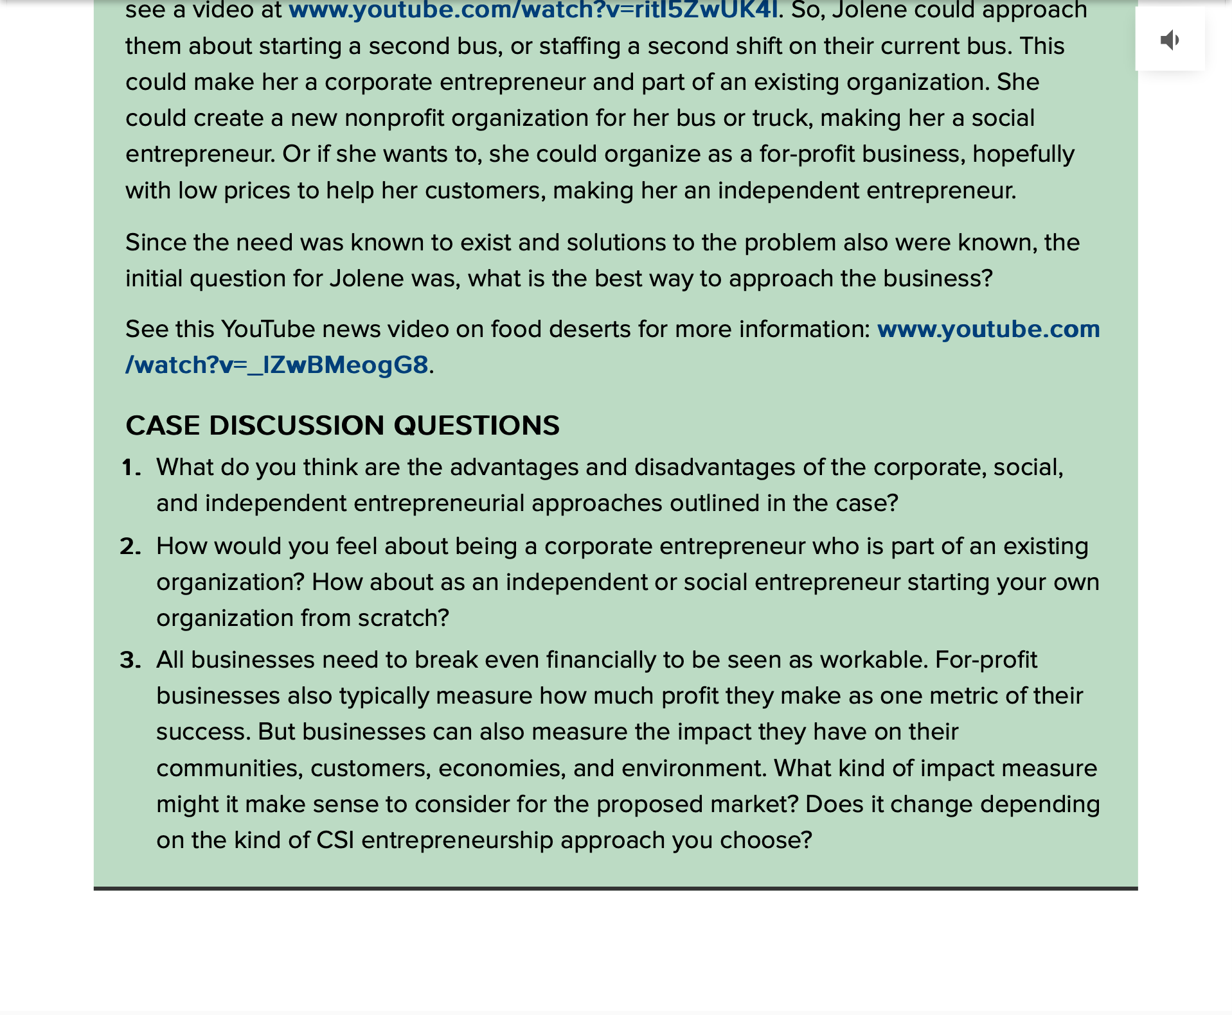
https://www.ers.usda.gov/data-products/food-access-research-atlas/

https://www.stlmetromarket.com/)

https://www.youtube.com/watch?v=ritI5ZwUK4I

https://www.youtube.com/watch?v=_lZwBMeogG8

- Read Focus on Small Buiness " Focus on Small Business: Summer Albarcha and Controversial Skirt" on page 55 and 56 of your text book and also check out the videos associated with the this case linked below.

See Summer’s YouTube channel at www.youtube.com/channel/UCZaBtpOjMtP2gmLenyOGNIg
To hear Summer talk about the Mimu Maxi story, see www.youtube.com/watch?v=NFtI00mwy48
Discussion Questions:
  - How would you describe the different types of relationship between Mimu Maxi and Summer’s Instagram page?
  - Do you think the extremely negative reactions for a subset of customers or followers is a typical response? If not, what do you imagine is typical?
  - How would you have handled the reactions of the upset followers?
